# Lab 12

Instructor: Sidra Khatoon E-mail: skhatoon[@uit.edu](mailto:ad@uit.edu)

# Objective

# The objective of lab is exploring login page and form validation

# .

**Student Information**

|  |  |
| --- | --- |
| **Student Name** |  |
| **Student ID** |  |
| **Date** |  |

**Assessment**

|  |  |
| --- | --- |
| **Marks Obtained** |  |
| **Remarks** |  |
| **Signature** |  |

# Objective

# The objective of lab is exploring Drawer and tab Navigation.

# Instructions

You have to perform the following tasks yourselves. Raise your hand if you face any difficulty in understanding and solving these tasks. **Plagiarism** is an abhorrent practice and you should not engage in it.

# How to Submit?

Submit lab work using Teams.

**Login Page:**

It’s a good practice to authenticate users before giving access to websites, mobile apps, computer applications to prevent unauthorized access to personal information. In this lab we learn how to build a login page user interface. We have used form widget of flutter to create login page. We have used the TextFormField widget, for user input as username and password. Elevated Button widget, to show action.

**Form Widget:**

The Form widget is container for form field in flutter. It helps in managing form state, validation and submission. Its act as a parent widget for form filed and provides methods and properties to handle form-related operations. In the provided code, the form widget is used as the parent of from fields.

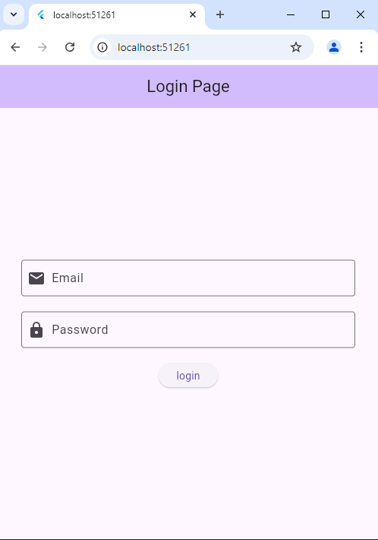

**Textfield Validation:**

**Form widget GlobalKey<FormState>**

The key property of the form widget is used to assign a unique identifier to the forms. It is necessary to associate the form with a GlobalKey<FormState> so that we can access and manipulate the form’s including form validation and submission

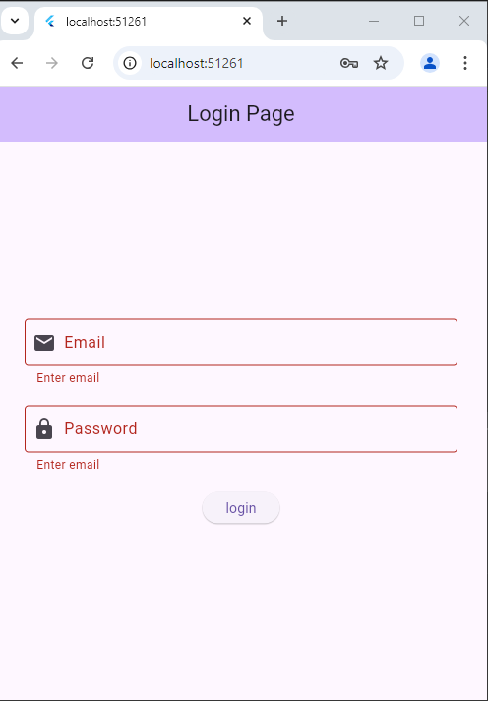

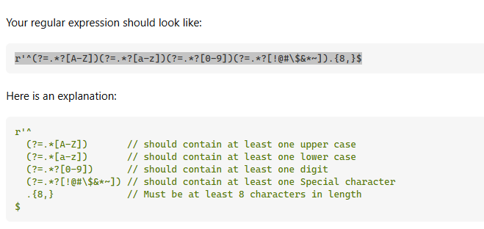

**Assessment:**

Create a Signup or registration page with different Textfield. Form consists on Name, Email, phone number and password. On register button you will navigate to the homepage. Apply validation on all fields by using regex expression.